Secret Status：Top Secret ( √ ) Secret ( √ ) Restrict ( √ ) Public ( √ )

RKNanoD Firmware Structure and Boot Sequence Guide
(Version 1.0)

Product R&D Dept.III
Fuzhou Rockchip Electronics Co., Ltd
www.rock-chips.com

Status：  [√] development  [√] public  [√] modify | File Tag： | Firmware Structure and Boot Sequence
Status：  [√] development  [√] public  [√] modify | Version： | 1.0
Status：  [√] development  [√] public  [√] modify | Author： | Tony.Zheng
Status：  [√] development  [√] public  [√] modify | Data： | 2015-08-02
Status：  [√] development  [√] public  [√] modify | Verify: | Miriam.Wang | 2015-08-04

Version History
Version | Author | Date | Remarks
1.0 | Tony.Zheng | 2015-08-02 | Initial Release

Index
1 Introduction 5
2 Memory organization 6
3 Software Block Diagram 7
4 Firmware Structure in Flash Storage 8
5 Boot and upgrade Sequence 10
6 Concluding Remarks 12

Introduction
This document introduces the RKNanoD firmware structure stored in flash memory and the boot sequence during the system powers up.

KEY words table:
BOOT ROM | It is the ROM memory in RKNanoD that includes software code to boot system.
FLAH BOOT | It is the software resided in RKNanoD ROMused for booting the system from FLASH memory.
USB BOOT | It is the software resided in RKNanoD ROM used for booting firmware and upgrading sequence via USB.
LOADER | It is the software stored in external FLASH memory used for booting system and upgrading firmware
FLASH LOADER | It is the software stored in external FLASH memory used for booting system.
USB LOADER | It is the software downloaded from USB for firmware upgrading.
SYSTEM code | It is the RKNanoD SDK software code developed by Rockchips or other developers.
SYSTEM data | It is the RKNanoD SDK software data developed by Rockchips or other developers.
SRAM | RKNanoD SRAM includes PMU SRAM,SYSRAM0,SYSRAM1,HIGHRAM0 and HIGHRAM1
ID BLOCK | It is the FLASH blocks used for saving index information of RKNanoD firmware
IRAM | It is the RKNanoD SRAM portion used for storing software code, which can be assigned to PMU SRAM, SYSRAM0, SYSRAM1, HIGHRAM0 or HIGHRAM1 by software.
DRAM | It is the RKNanoD SRAM portion used for storing software data,which can be assigned to PMU SRAM, SYSRAM0, SYSRAM1, HIGHRAM0 or HIGHRAM1 by software.

Memory organization
RKNanoD is a processor with dual Cortex-M3 core (including system core and calculation core) , low cost, low power consumption and high performance. Both system core and calculation core can access all memories in RKNanoD.
The memories include 16KB boot ROM and 320KB SRAM. The boot ROM is inalterable and it is used to store the boot code. After system powers on, the boot ROM code is executed first at the address 0x00000000. The SRAM is divided into 5 portions, which include 64KB PMU SRAM, 320KB SYSRAM0, 256KB SYSRAM1, 128KB HIGHRAM0, 256KB HIGHRAM1. In the RKNanoD MP3 SDK, the SYSRAM0 and SYSRAM1 are used for data and code which run by system core. The HIGHRAM0 and HIGHRAM1 are used for code and data which run by calculation core for audio decoding and encoding.
All the SRAMs can be powered down except PMU SRAM. The PMU SRAM can be used to store the code and data which can resume the system from SLEEP mode. The PMU SRAM supports memory remap. If the memory is remapped, the addresswill start at 0x00000000 which is the first address accessed by CPU when system powers on or resumes.
The following block diagram shows the RKNanoD memory map:
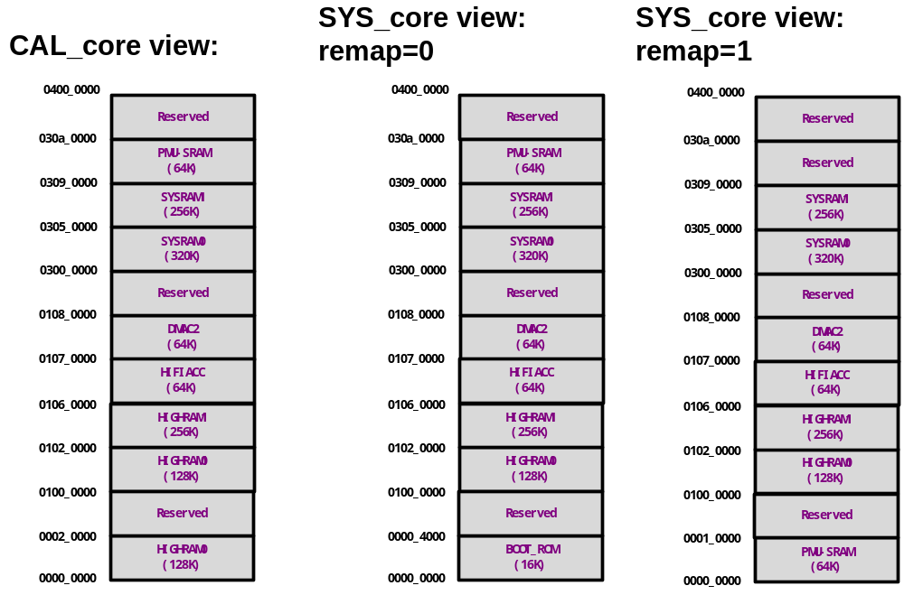

Software Block Diagram
RKNanoD boot sequence includes 3 parts — boot ROM, LOADER and SYSTEM. The boot ROM address starts at 0x00000000. So after system powers up, the boot ROM will be executed first. The boot ROM is consist of FLASH BOOT code and USB BOOT code. The FLASH BOOT code reads firmware information from eMMC flash or SPI flash, and loads FLASH LOADER to SRAM. If it fails to get firmware information or to load FLASH BOOT, the USB BOOT will be executed. The USB BOOT is used for downloading USB LOADER from PC with RKNanoD upgrade tools.
The LOADER is divided into two parts - FLASH LOADER and USB LOADER. If the FLASH BOOT is finished, the FLASH LOADER will continue to load SYSTEM code and data from eMMC flash or SPI flash to SRAM. After the SYSTEM code and data has been loaded to SRAM successful, the boot sequence will be finished. If the USB BOOT is finished, the USB LOADER will continue to download the firmware from PC with RKNanoD tools to eMMC or SPI flash. If USB LOADER has been executed successful, the “firmware upgrade” sequence will be finished.
The SYSTEM is the RKNanoD software SDK which includes RKNanoD system and other applications code and data.
The following diagram shows the RKNanoD software blocks:
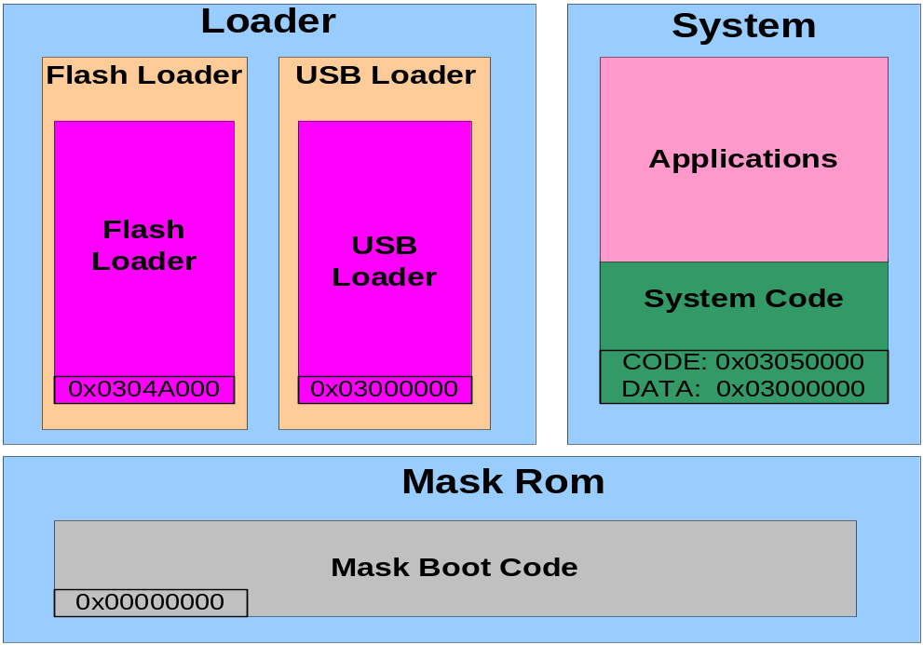

Firmware Structure in Flash Storage
The RKNanoD firmware is stored in eMMC FLASH, SPI NOR FLASH or EMMC FLASH. The following block diagram shows organization of the firmware stored in eMMC FLASH.
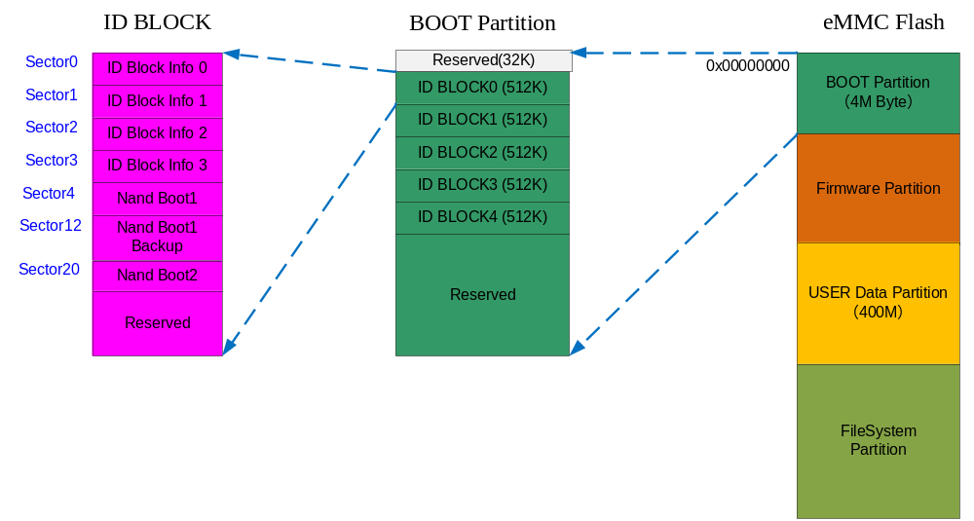
The eMMC flash is divided into several partitions – BOOT partition, firmware partition, USER data partition and file system partition.
The BOOT partition saves 5 ID BLOCKs which include firmware information and LOADER. RKNanoD uses the ID BLOCK1 ~ ID BLOCK4 as the copys of ID BLOCK0 to improve the robustness of the RKNanoD firmware stored in eMMC flash.
The firmware partition saves the RKNanoD SDK firmware which is developed by ROCKCHIP or other developers. There is also a copy of the firmware stored in this area to improve the stability of RKNanoD system. If one firmware has been detected error, the other firmware will be used for starting the system and fixing the error firmware.
The USER data partition is an area used for storing user data such as database, system information.The size of USER data partition can be configured by software.
The file system partition is formatted as FAT32 file system for storing user data.
The following tables show the structure of RKNanoD ID BLOCKs. The BOOT code gets the information from eMMC FLASH to ensure RKNanoD firmware and load LOADER into SRAM.
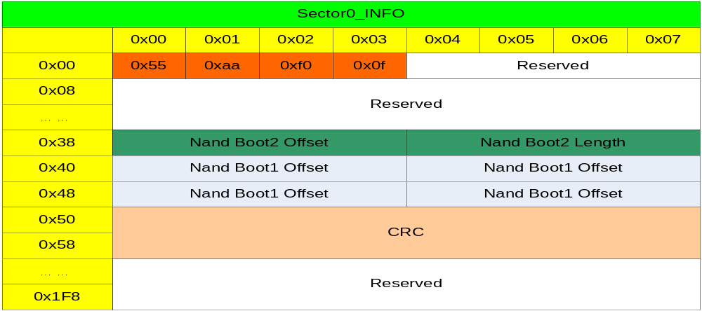
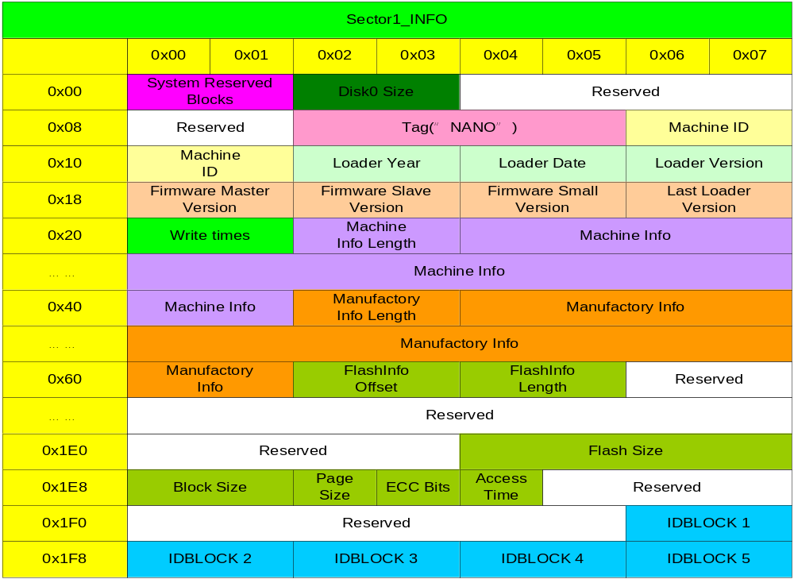
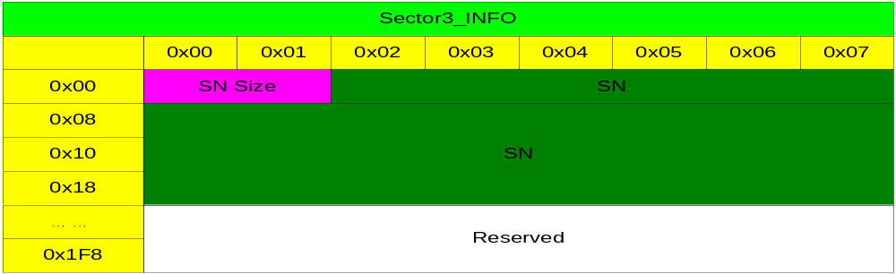

Boot and upgrade Sequence
RKNanoD boot sequence and firmware upgrade schematic diagram is shown as below:
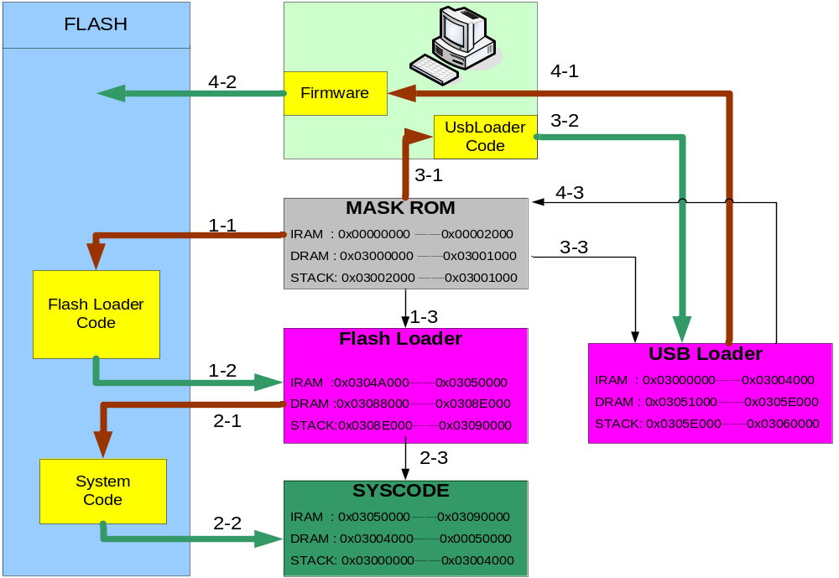

The RKNanoD boot sequence is shown as in 1-1 ~ 2-3:
1-1: When the system powers on, the FLASH BOOT code is executed first at the address 0x00000000 in BOOT ROM and checks the ID BLOCKs information..
1-2: The FLASH BOOT reads ID BLOCKs information and loads FLASH LOADER from eMMC FLASH BOOT partition to SRAM, the code loads to address 0x0304A000 and data loads to address 0x03088000.
1-3: PC pointer jumps to SRAM at the start address 0x0304A000. Then the FLASH BOOT is finished.
2-1: After the FLASH BOOT loads FLASH LOADER to SRAM and PC pointer jumps to FLASH LOADER, the FLASH LOADER will start to run and check firmware information.
2-2: FLASH LOADER loads SYSTEM code to address 0x03050000 and SYSTEM data to address 0x03004000 from eMMC FLASH firmware partition to SRAM.
2-3: FLASH LOADER is finished after the PC pointer jumps to SYSTEM code at the start address 0x03050000 in SRAM.
Then the RKNanoD boot sequence is finished.
The RKNanoD firmware upgrade sequence is shown as in 3-1 ~ 4-3:
3-1: The USB BOOT will be executed if the boot sequence is failed or firmware upgrade is needed. The USB BOOT connects to PC via USB cable, and the connection is established with firmware upgrade tools.
3-2: The firmware upgrade tools downloads USB LOADER to RKNanoD SRAM to the address 0x03000000.
3-3: PC pointer jumps to USB LOADER at the start address 0x03000000 to run USB LOADER code.
4-1: USB LOADER starts to continue to establish the connection with firmware upgrade tools.
4-2: USB LOADER gets firmware information and downloads ID BLOCKs and firmware into eMMC FLASH.
4-3: After the downloading and firmware checking have been finished, RKNanoD will reset and start the boot sequence.
The software flow chart of boot and upgrade is shown as below:
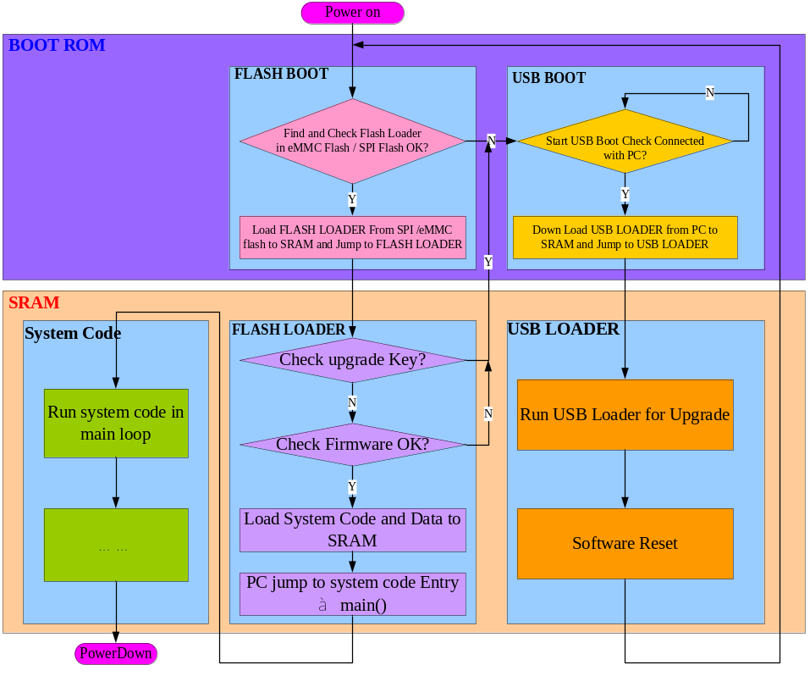

Concluding Remarks
Due to BOOT ROM is unmodified, BOOT ROM is designed simple and stable. However, as the LOADER can be modified, it can be designed flexible. RKNanoD uses BOOT ROM and LOADER to boot the system, which can ensure software booting to be stable and flexible.

